MASS REMOVAL & DENTAL SURGERY RELEASE FORM

The Veterinary Clinic
The Veterinary Clinic West

Owner Name: _____________
Patient Name:_____________
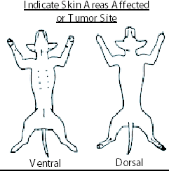
Please circle the area of the mass(s) that will be removed today.

Procedure to be performed:_ DENTAL AND MASS REMOVAL_____

I hereby consent and authorize the doctors & associates of The veterinary clinic/West receive, prescribe for, treat, and/or operate upon PET NAME: ___________________________
If your pet should become ill while with us we will take all necessary measures to save its life. Should an animal die while in our care we reserve the right to perform an autopsy. We request that you leave us a contact phone number when you place your pet in our care.
In case if an abandoned animal, written notice will be sent to the address given at the time of check in. Five days after such notice the animal will be considered abandoned and can be handled as provided by law. It is understood that this does not relieve you from paying all costs of services, hospitalization, and boarding.
The Veterinary Clinic/West’s visitation policy is as follows: You have the right to visit your pet during normal clinic hours.
*** All pets admitted to this hospital must be current on Rabies vaccination and upper respiratory vaccination within this calendar year. If your pet is not current we will administer the vaccination and there will be additional charges. ***
Has your pet had anything to eat or drink past midnight? Y / N
Is your pet 7 years or greater? Y / N
Do you approve of extractions, if they are necessary? Y / N ______
***EXTRACTIONS CAN COST FROM $50-$200.00*** initials

What medications is your pet taking? When was the medications last given? ________________________________________________________________________________________________________
I have read the above and agree

Signed__________________________________ Contact phone number:_____________________________

Case Manager signature: _________________________________________________

------------------------------------------------------------------------------------------------
For hospital use only
Time | HR | RR | CRT | Temp | SpO2 | BP | Iso rate | Comments

