MASS REMOVAL SURGERY RELEASE FORM

The Veterinary Clinic
The Veterinary Clinic West

Owners Name:

Patients Name:
_________________________

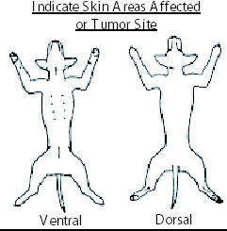

Procedure to be performed: ___MASS Removal________________

I hereby consent and authorize the doctors & associates of The veterinary clinic and veterinary clinic west receive, prescribe for, treat, and/or operate upon _______________ (pets name).
If your pet should become ill while with us we will take all necessary measures to save its life. Should an animal die while in our care we reserve the right to perform an autopsy. We request that you leave us a contact phone number when you place your pet in our care.
In case if an abandoned animal, written notice will be sent to the address given at the time of check in. Five days after such notice the animal will be considered abandoned and can be handled as provided by law. It is understood that this does not relieve you from paying all costs of services, hospitalization, and boarding.
TVC/TVC-W’s visitation policy is as follows: You have the right to visit your pet during normal clinic hours.
*** All pets admitted to this hospital must be current on Rabies vaccination and upper respiratory vaccination within this calendar year. If your pet is not current we will administer the vaccination and there will be additional charges. ***
Has your pet had anything to eat or drink past midnight? Y / N
Is your pet 7 years or greater? Y / N
Would you like a micro-chip implanted for permanent identification? Y / N
(If yes, there is an additional charge of $75.50)

Is your pet on any medication?
____________________________________________________________________________________________________

I have read the above and agree:
Signed: __________________________________ Contact phone number: _____________________________

Case Manager signature: ____________________________________________

-----------------------------------------------------------------------------------------------------------------------
For Office Use Only
Time | HR | RR | CRT | Temp | SpO2 | BP | Iso rate | Comments

